Appointment System

User Manual

Version 8.02, September 8, 2022

This appointment system was developed by AARP Foundation Tax-Aide volunteers from Colorado to replace various paper or spreadsheet type systems. It provides a convenient platform for managing appointments for individual sites, coordination of scheduling across multiple sites, or a central scheduling point for many sites. New sites and users can be added by any Appointment Manager and users can be assigned either viewing or scheduling permissions at their own or multiple sites as desired. Sites can optionally allow internet access to taxpayers for scheduling their own appointments or add themselves to a callback list for subsequent scheduling.

**TABLE OF CONTENTS**

Scheduling 3

Views 3

Menu Line 3

View Selection 3

Site List 4

Calendar 4

Appointment area 4

Summary view 4

Daily view 5

Callback list 6

Deleted list 6

User view 7

How to… 9

add an appointment 9

move an appointment: 10

copy an appointment: 10

delete an appointment: 10

send email: 10

Click to send an email to the taxpayer. Be sure you have saved any changes – this will close the window. 10

Site Management 11

Configuring appointments 11

Export site data to Excel 13

Site Options and Permissions 14

Add a new site 17

Schedulers and permissions 18

Change permissions 18

Add a new scheduler 19

Taxpayers list 19

Appendix 1 20

OPTION 1 - USE RESERVED SLOTS 21

OPTION 2 - SETTING UP A SECOND SITE 23

NEW TAXPAYER PROCESS MESSAGE 26

TAXPAYER TRACKING 28

# Scheduling

## Views

Each view has a menu line, a view selection box, a site list, a calendar, and an appointment area.

|  |  |
| --- | --- |
| Menu Line | |
| View selection | Appointment area |
| Site list |
| Calendar |

### Menu Line

|  |
| --- |
| The search menu allows you to find a scheduled taxpayer by tag, phone number, name, or email. If searching by phone, include dashes. |
| The reports menu provides a variety of reports. The check-in list and ERO checklist are only available when in the daily view. Export to Excel is only available if you have permission to make appointments. |
| The Tools menu is used to set up appointments and to set up options for the site and user permissions. This is only available to Appointment Managers. |
| The Help menu takes you to this document or to a website for your home site if one has been set up by your Appointment Manager. It’s a great place to put specific procedural instructions for your site. |

### View Selection

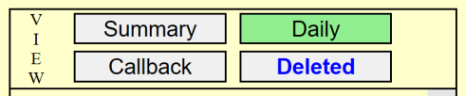There are five different views that differ in the Appointment area. The desired view is selected by buttons which indicate the current view with a green color, or views that are not accessible (perhaps when moving an appointment) with a red color. Additionally, the text in the “Callback” or “Deleted” view buttons will have blue text if a taxpayer has added or removed their name via internet scheduling – you may want to follow up with them. The blue text will return to black after any action is made for that appointment record.

### Site List

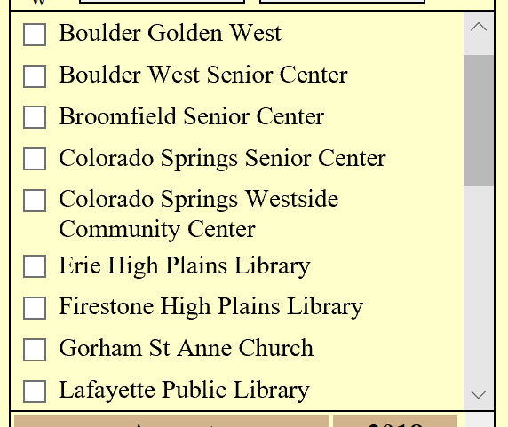The site list section shows the sites available for scheduling. For each box checked, the appointments related to that site will be shown in the appointment area of the view. To check multiple boxes, hold the PC Ctrl key down as you click each box (check or uncheck). When you release the Ctrl key, the view will refresh to the new configuration. The list will only show sites that you have been given permission to access.

### Calendar

The calendar shows the availability of appointments for each date. The current date has a box around it. A green background indicates that appointments are available; red indicates all appointments are filled or is a date prior to the current date; orange indicates that all appointment times for that date have been reserved (more on that later). If the date number is shown in blue, an appointment on that date has been made by a taxpayer using internet access and you may wish to follow up with a phone or email contact. Hover over the date to see how many appointments are available on that day and how many are reserved.

Click on the date and you will jump to the daily view for that date.

### Appointment area

The appointment area lists the times available for scheduling or names that are on the callback or deleted list. The details vary with the view.

#### Summary view



The Summary view shows the status of all appointments, listed by date and time. For each date there are time boxes, the color of which indicates the availability of appointments and whether some appointment slots are reserved. The number in parentheses in the time box indicates the number of appointments available for scheduling and may or may not include reserved slots, depending on your site option.

Normally, only dates starting with the current date are shown but there is a checkbox above the first date titled “Show all dates” that allows showing earlier dates to view the past history. Use the site checkboxes to indicate the appointment slots for which sites you wish to see.

Click on the time box to bring up the appointment registration form.

Click on the date column area or the date on the calendar to move directly to the Daily view.

#### Daily view



Clicking on the Daily view button will open to the date with the first available appointment slot.

The Daily view shows the details of the time slots available for the sites checked in the site list for that date, listed in time order. Available appointments are highlighted in green (either RESERVED or not). Clicking on an available appointment will allow assigning that appointment using a scheduling form (described later). Clicking on an assigned appointment will allow changes to the scheduling form or moving the appointment to a different location, time or date or deleting the appointment.

The name column is free-format. Whether you use first- or last-name first is a site procedure decision. Click on the circled “R” to make an idle slot reserved or unreserved.

The bolded text in brackets (see Nancy Drew above) is a free-format field for entering information that you may wish to search for later. You could use specific “tag” words or longer text as shown. This information does not print on the check-in list or the ERO checklist.

The phone number is forced to be 7- or 10-digits with an optional 1- and is required. Alternate phone numbers could go in the Info column. If the taxpayer does not have a phone, use 000-000-0000. The link shown in the example is a function of your browser. If the system you’re using has the capability, clicking on that link will open a phone function and you can use that to call the taxpayer (not on most PCs, but possibly on a tablet or for sure, a cell phone).

If the Note column has a checked box in it (see Jack Spratt), there is a note in the scheduling form and hovering the mouse over the box will display that notes. The note will print out as a footnote on the check-in list.

If the Info column has a warning symbol (see Charlie Chaplain), there is information in the scheduling form and hovering the mouse over the box will display that information.

The Status column shows the most recent action taken on behalf of the taxpayer with date, time, action taken and who took that action – a good reason for each Scheduler to have their own personal login. To see the entire text of the latest action, hover the mouse over that cell in the table. If the Status cell has a blue background, it indicates that the taxpayer has made the entry via the internet and you may wish to follow up to verify their need to file or if they have any scope issues. Once such a contact or other action is made, the blue background goes away and the text turns black.

If you move a taxpayer to a new time and date (as with Jack Spratt above), the appointment number is highlighted in gold to make that move easy to identify to help you assure that the move was successful. When any action is made, that highlight goes away.

*For Appointment Managers only*, the red minus(-) and plus(+) boxes are quick ways to add or remove empty slots to that time period without using the Configurator. It will not remove a slot that is being used nor one that has been RESERVED. Also, at the bottom of the list of appointments is an option to allow adding a time group to that date for any site for which you have Appointment Manager permissions.

#### Callback list

The Callback list is similar to the Daily view and shows all taxpayers that are awaiting appointments after a phone (or personal or email) contact from a taxpayer requesting an appointment. Each site selected on the site list will have its callback list shown. As with the Daily view, blue highlighting in the Status column means that a taxpayer has entered their name on the Callback list via the internet.

If you are not in a position to make the appointment, add the new contact in the green line at the bottom of the list. A new green line will appear for the next new taxpayer.

When ready to make the appointment, clicking on an existing name will allow changes to the client information on the appointment form, moving the taxpayer to an assigned appointment or deleting then taxpayer’s entry if you are only answering the taxpayer’s questions.

The bottom “Click to add…” option is for the rare case when in using an answering machine that forces one to get the most recent messages first, you can explicitly add the number of expected messages as “Reserved for #1” through “Reserved for #n” entries and use them to enter the answering machine messages in reverse order. These can only be added to the scheduler’s home site.

When a person is moved to or from an appointment or from the Deleted list, their number entry in the Callback list is highlighted in gold as described earlier so that they are easier to find if need be.

#### Deleted list

The Deleted list is identical to the Callback list without the “Click to add…” option.

Names on the Deleted list cannot be removed until the Appointment Manager specifically removes them. This preserves the history of the site’s handling of the taxpayer in the event of questions or the need to review actions taken by Schedulers for a particular taxpayer.

Taxpayers can always be moved back to the Callback list or to a scheduled appointment from the Deleted list.

#### User view



The User view is similar to the Summary view and lists all sites open for internet scheduling but only one site can be selected at a time. It only shows available schedule dates and times, and allows the taxpayer to add themselves to the callback list if they have questions.

This view is not available to the Scheduler and the taxpayer does not have access to other views.

If the site name is followed by a dagger notation, no schedule is shown and the user can only add their name to the callback list (see Florence Senior Community Center above).

When a choice is made, the taxpayer will be presented with a box which auto-fills with their login information. They can modify this information and add to the notes section to provide additional information.



The screen will then show a list of appointments made by the taxpayer.

If the taxpayer is limited by the number of appointments they can make using the same email, the schedule is no longer shown and a message indicating the limitation is presented.



Appointment schedulers should always look for the blue highlighting that results from a taxpayer who has registered via the internet to be sure that there no questions to be answered or other follow-up needed. Click on one of the contact history buttons to clear the blue.

## How to…

add an appointment:

From the Summary View, click on a green- or yellow-highlighted time box to bring up the appointment form. If the Appointment Manager allows the option to schedule RESERVED slots from this view, you can also click on the orange-highlighted time box. If not allowed in this view, you will have to go to the daily view by clicking on the date box or calendar day to use them. Empty, non-RESERVED, slots will always be chosen first.

From the Daily View or the callback list, click anywhere on any green line, RESERVED or not, and the appointment form will appear. Individual schedulers may or may not have permission to make reservations on the RESERVED slots.

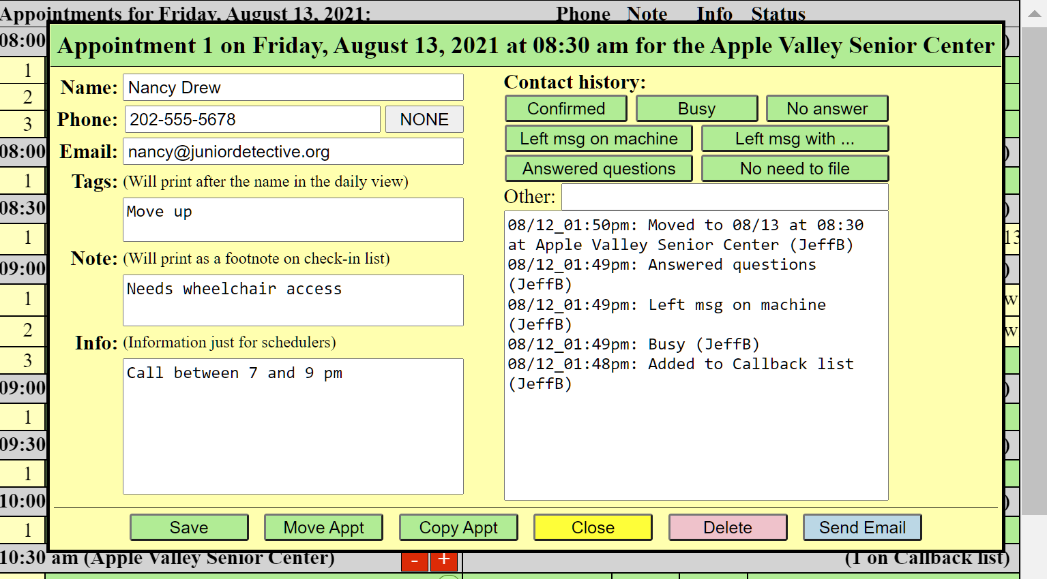

As a minimum, enter the client name(s) and phone number in the pop-up box and click "Save". An entry will be automatically added to the Contact history section. Both are required. If there is no phone number, enter 000-000-0000 (click the NONE button).

If you enter an email address, an email will be sent to the taxpayer when you schedule or move the appointment if set up by the Appointment Manager to do so. If a taxpayer makes their own appointment from the internet, the email address is required and thus will also result in the confirmation email. A note that the email was sent will be added to the contact history list.

There are three boxes for adding additional information. Why 3? Experience has shown that many schedulers were adding additional “codes” after the taxpayer’s name to be used for searching or to catch attention for a particular situation. While functional, it added clutter to the check-in and ERO reports. Thus the different ways to provide additional information…

Tags: If there reasons to search for the taxpayer other than by name, phone, or email, you can add a “tag” in the Tags box. For example if there are those who ask for earlier appointments should a cancellation occur, you might add “Move up” in the Tags box. The tag will appear after their name in the schedule screens enclosed in brackets, for example: **[Move up]**.

Notes: If the client has a special need, enter it in the Notes box. This is a good place to indicate any physical or mental challenges, interpreter needs, other tax year or amendment to be done. This information will print as a footnote on the check-in list.

Info: Other information such as questions the taxpayer may have or concerns that need to be addressed during scheduling can be entered in the Info box. This is shared with the appointment schedulers and is not printed on the check-in list.

|  |  |  |
| --- | --- | --- |
| Name: | searchable | Prints with the name on all reports |
| Tags: | searchable | Displays with the name in appointment screens only |
| Notes: | not searchable | Prints as a footnote on the check-in list only |
| Info: | not searchable | Only displays in the appointment detail window |

Whenever you contact the taxpayer, add a new entry in the "Status" area to indicate the action. The most common entries have their own button. If you need some other statement, just enter it in the “Other” box and it will be added when you exit the box – no need to add the time stamp or your name.

If you have done this from the Summary view, after you click "Save", you will automatically move to the daily view and the entry you made will have a highlighted number in the first row to help you find it to verify that it did what you expected.

If more than one person is making appointments at the same time, there is a chance that you both will choose the same time slot. If that happens, the first one to click “Save” will get the time slot and the other will get a message to try a different time. If significant time has passed, it’s always a good idea to click on the date or summary view button to refresh your screen to show the most current status.

**Whenever any change is made, be sure to click “Save” to save the change! “Close” will close the window without saving the changes.**

move an appointment:

From the Daily view, click on the current appointment line and chose "Move Appt". This will open a box that indicates that you are moving an appointment:

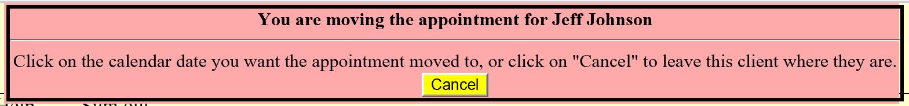Click on the desired new calendar date, the Summary view button, Daily view button, or Callback list button, find a new empty slot and click on it. That’s all there is to it. Again, the new entry will have the slot number highlighted so you can easily find it to verify that the move worked as expected.

If you have permission from other sites, you can even add or move appointments to other sites.

When you move the appointment, an entry will automatically be added to the History list and a new email will be sent to the taxpayer confirming the new appointment if they have an email address in their record and the Appointment Manager has opted to have emails sent.

copy an appointment:

You can copy an appointment in the same way as moving it. The only difference is that the original appointment is retained. This makes it easier to re-schedule a taxpayer for a return visit if needed.

delete an appointment:

You can’t actually delete an appointment entirely. To move an appointment to the Deleted list, simply click on the “Delete” button and it will make that change and record the action in the History list. That taxpayer can always be re-scheduled or added to the Callback list if needed.

send email:

Click to send an email to the taxpayer. Be sure you have saved any changes – this will close the window.

# Site Management

## Configuring appointments

From the Tools menu, select “Configure appointment slots” to open the configurator window.

A number of options are available as Tasks and as each task is selected, the required data needed is displayed.

Add new appointment slots

To configure your appointments, select “Add new appointment slots”, your site Location name, the days of the week you will be working and the date range. Enter the number of slots at each time group and if any should be RESERVED.

Click “Go” and you’re done!

The purpose of making some slots RESERVED can serve several purposes:

* They can never be selected by taxpayers who self-register from the internet.
* They can give some flexibility in scheduling to “see how things go” particularly at the beginning or end of the day or around lunch time.
* They can be used to assign times for taxpayers that have significant work remaining when they must return.

If different work days have different schedules, the Add option can be used multiple times and if duplicate times are encountered, it will add the specified number of slots to those already present.

You may wish to save your appointment pattern before you click the “Go” button. You can then recall that pattern to be used later.

* Perhaps one of the Mondays is a holiday but is one of your normal work days. Just recall your pattern and add for the dates prior to the holiday, and again for the dates after the holiday.
* If you have multiple sites using the same or similar schedule, recall a saved pattern, change the site name and then save it (or as modified) to the new site or simply click “Go”.
* If you want to remove some unused appointments, recalling the saved pattern can save time inputting the original data. Just change the dates and the number of slots to be removed.

Clear names from existing slots

If you use your real schedule for training, you can use the “Clear” option to remove names from your schedule so that you can start fresh with real taxpayers. *You never want to use this option during the working season.* It will not remove the deleted list – you will need to do that separately.

Delete all in the callback list

This option moves all in the callback list to the deleted list. Rather than remove these entries, moving them to the deleted list preserves the taxpayer’s history until the end of the season, at which time it is safe to fully remove the season’s records (after exporting the records for possible future reference).

Clear and remove the deleted list

This option is often used with the previous one when you wish to clear out your schedule. It’s a good idea to not use this option during the working season because you will lose the historical information about taxpayers you have determined no longer require appointments.

Remove unused appointment slots

If you mistakenly created too many time slots for a date or time, you can use the “Remove” option to remove them.

This option will not remove any slot with a name entry, including RESERVED. This makes it safe to use during the working season.

Remove all appointment data between specified dates

This option allows removal of appointment time slots and its data between two dates (inclusive). You should not use this option to remove data for dates in the current working period unless you know they contain no working data (like a holiday, for example).

It does not remove callback or deleted data that may have occurred between those dates.

Start over – remove all appointment data

The “Start over” option is the preferred way to totally clean out your appointment schedule and will also clear the Deleted list. With this option, the only entry presented will be the site name. You may wish to export your data to Excel before using this option and you certainly will not want to use it during the working season.

If you have saved your appointment pattern(s), this is an easier way to restore your schedule than clearing the names and removing the deleted list.

Clone schedule from previous year

If you were completely happy with the previous year’s schedule, put in the new year’s date range and it will attempt to duplicate what was set up the previous year. Examine the first and last dates and holidays carefully because there may not have been an equivalent schedule for those days the previous year due to the way the calendar dates shift. RESERVED slots are not preserved as such but created as normal non-RESERVED slots since they will have likely changed during the previous year.

Adjustments can always be made from the Daily view.

This option will also clear the Deleted list and all data prior to your new starting date.

## Export site data to Excel

There may be occasions when a spreadsheet of appointments and/or taxpayer information is needed. You can export data from one or more of your accessible sites, as selected in the site list.

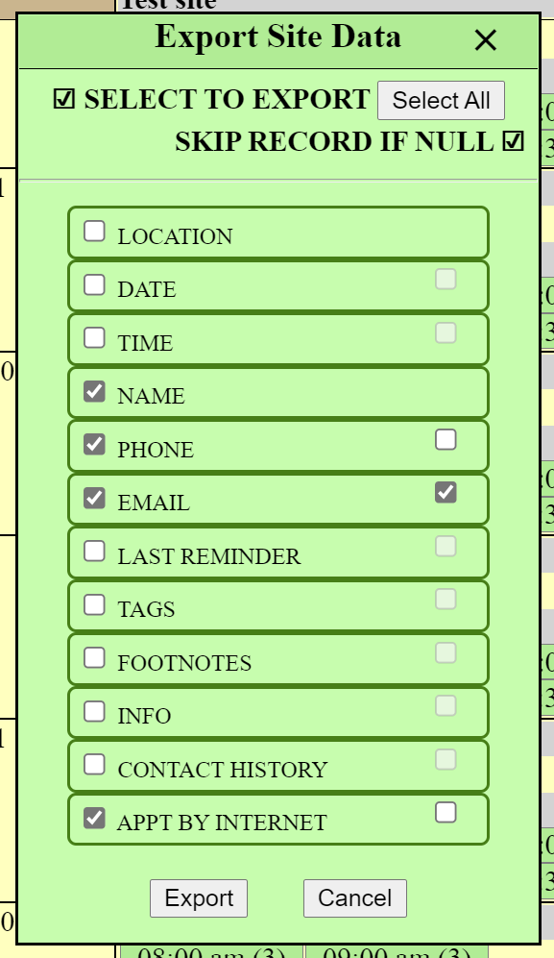This is done from the Reports menu.

A list of available data fields will be presented over the current window. Select the fields you wish to export by checking the box to the left of the field name.

You can re-arrange the fields by dragging the field box into a desired position. The selected fields do not have to be adjacent to one another and unselected fields are not included in the resulting export file.

The export file is always sorted by LOCATION, DATE, and TIME. Use Excel to sort the data in other ways if you wish.

On most fields, there is a box on the right side which, if checked, will normally skip any records that has no information in that field. The example here indicates that a record will not print if there is no email. Some fields, like LAST REMINDER, work the opposite – it will only print if there was no last reminder. Hover over the checkbox to see what the condition for that field is.

The resulting file that is created is a tab-separated text file with an “.xls” file type.

Your arrangement is saved as a cookie on your PC so that the same report will be produced the next time you decide to do an export.

## Site Options and Permissions

Site options and user permissions use the Site and User Administration screen accessed from the Tools menu or from the login window. This is only available to the site’s Appointment Manager. There are three tabs on the screen:



Menu items allow you to switch to the Manage appointments screen described earlier, to search for a person by name, phone or email, and to sign out. The search menu only locates persons who are able to log into the system – it will not find persons nor specific appointments from the appointments screen.

The top box below the menus indicates the Site being managed. If you have access to more than one site, this is where you choose which one for which you want to set options.

Besides your home site, there is a site called “unassigned” for which you cannot set any options nor change its name. This allows access to the list of Taxpayers who have logins but have not made an appointment at any particular site.

The Site Options tab lists all the options available to the site. All but the site name is optional but the other site information is important and an appointment Email contact is required if you will be sending emails to taxpayers as confirmation of their appointment.

*Email messages option:*

To enable email messages, click on the option box and additional fields will be displayed

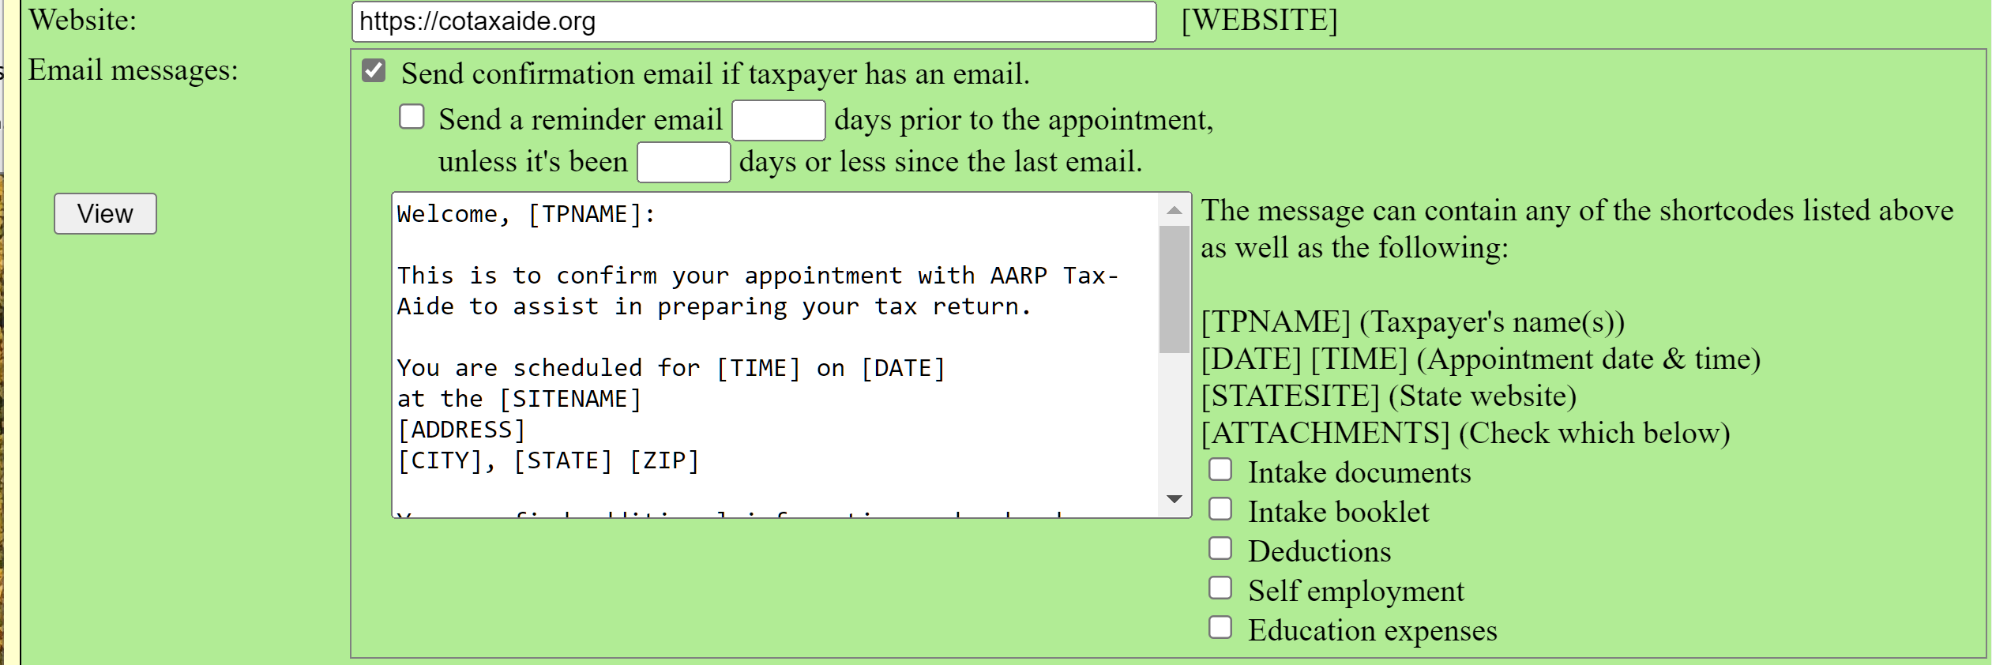

The email message can be edited as desired and the [shortcodes] will be replaced with the corresponding real information when the email is sent. You may want to modify the message with additional specific information or instructions unique to your site or to delete some of the information in the default message.

New in Version 8.0 is an [ATTACHMENTS] shortcode. The list that follows is set up by the system administrator and you can select the attachments you want to include in the email by checking the appropriate box(es). This does not produce a proper email attachment but results in a list of the attachments and their web address. Hover the mouse over the checkbox to see the web address.

You will want to put instructions prior to the list so the taxpayer knows what to do with them. For example:

Please download the following documents and bring them with you completed to reduce the time you will spend when you arrive at the Senior Center:

[ATTACHMENTS]

If you checked the 2nd and 3rd attachment boxes, the result will be:

Please download the following documents and bring them with you completed to reduce the time you will spend when you arrive at the Senior Center:

* Intake booklet (<https://cotaxaide.org/docs/book.pdf>)
* Deductions (<https://cotaxaide.org/docs/ded.pdf>)

This shortcode can also be used in the additional instructions message described below for those taxpayers who are making their own reservations online. The same list is produced in that message.

You can also specify individual attachments in-line by surrounding the document name with brackets:

If you have education expenses, also fill out the [Education expenses] document too.

**To revert back to the default message**, simply delete the entire message.

Emails are sent when an appointment has been made for a taxpayer or moved to a different appointment slot if the taxpayer has an email.

Click the view button on the left to see what the message will look like.

An additional option is to send reminder messages shortly before the taxpayer’s appointment. The number of days prior to the appointment is set, and to prevent the reminder from seeming like a nag, set the “unless it’s been” option to something larger.

*Site options:*



The option to “Allow scheduling of reserved slots in Summary View” is checked if you want the system to use RESERVED slots when an appointment is made by selecting a time box from the Summary View. Empty non-RESERVED slots are always selected first but you may wish for your Schedulers to go to the daily view so that the use of the RESERVED slots is deliberate rather than just because all the non-RESERVED slots have been used.

The original intent of RESERVED slots is to limit the number of appointments that an internet taxpayer can schedule in any particular time period so that the RESERVED slots can be used by your own Schedulers.

The option to “Require 10-digit phone numbers” is becoming a necessity given the number of people who are retaining their cell phone numbers as they move about the country. It is set by default but can be unchecked if this is not an issue for your site.

*Internet access options:*

Checking the “Internet access” box produces some additional options: 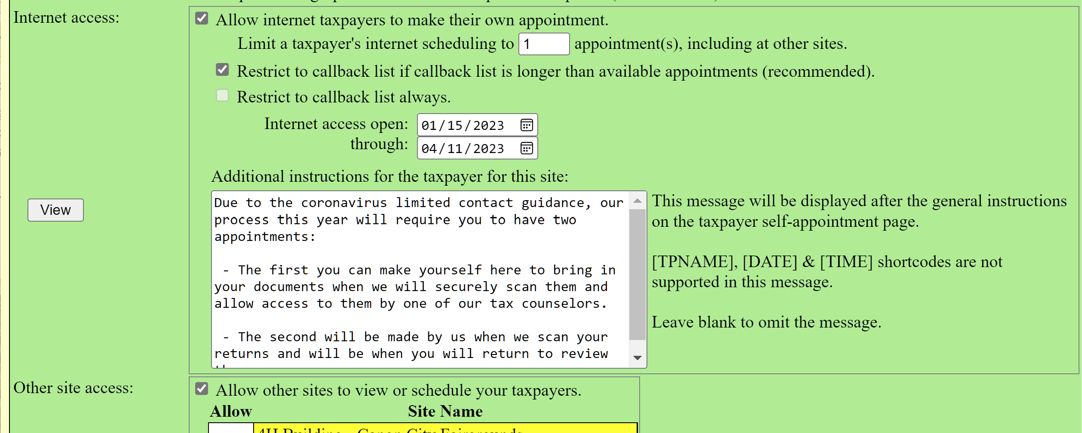

You can limit the number of appointments a taxpayer can make from the internet.

You can restrict internet users from only adding their name to the Callback list always, or only if the Callback list exceeds the number of available appointments, or no restriction at all. If you restrict the taxpayer to the callback list, a dagger will appear after your site’s name in the taxpayer’s User View.

You set the dates when internet access is open for scheduling. This causes your site to be listed on the sign-in window and if the current date is earlier than the opening date, the opening date will tell the taxpayer when to come back and try again.

You can give additional instructions to the taxpayer when they make their appointment by entering that information as text. (Do not paste directly from MS Word – some of the characters do not paste properly. Save the document as a text file first or use a text editor.)

*Other site access options:*

If you are cooperating with other sites in the appointment process, check the “Other Site Access” box. A listing of all of the sites using the appointment system will be listed:



Click on the associated “Allow” box to give another site the ability to schedule appointments or to see the availability (Summary view only) of appointments at your site. This brings up the list of all schedulers in that site to be displayed in your Schedulers tab. Then, in your Schedulers tab, you can assign permissions to your site on an individual basis. This does not affect their permissions on their home site. More about that later.

### Add a new site

You can add a new site by clicking the “Add a new site” button on the top left corner of this tab. It will open a new version of this same tab into which you will enter the name of the new site and its respective information. **Please always name the site beginning with the city name**.

Why add a new site?

* You have one or more ad-hoc sites
* You want to set up a virtual site to schedule taxpayers who must return to finish their returns
* To add a new site in your State split or District who wants to use the system (yes, you can do that)
* You have a team that provides services to the homebound and would like a way to keep track of their scheduling
* To independently schedule return visits (likely needed during the Coronavirus pandemic, for example)
* Other reasons I haven’t thought of yet.

When you add the new site, the “Schedule” box will automatically be checked next to the “Other site access” giving your home site permission to schedule on the new site and you become the Appointment Manager for that site as well as your own site. If you change that permission, you will not be able to manage the new site.

The new site will also appear in the drop-down list above the tabs so that you can easily switch back and forth between your own site and the new one.

## Schedulers and permissions

The Schedulers tab assigns the permissions to each individual who will be working in the appointment system.



It lists the Schedulers who have a home at any site to which you have given access in the Site Options tab. Your own current site is shaded in green and other sites are in yellow to aid in knowing which site you are currently administering if there are several to choose from (like the new one added in the Site Options tab). All Administrators are also listed.

Individuals can only be assigned to one “home” site and must have a unique email address. Other site managers will give those individuals permissions for the sites they manage by checking the boxes in the yellow areas.

### Change permissions

The defined “Roles” are:

* Administrator – only an Administrator can assign or remove Administrator permissions. They have access to all sites and schedules and can modify everything including the messages on the login window.
* Appt Manager – always has all permissions for the current site, can access the Tools menu and other configuration options in the appointment screens.
* Scheduler – can be configured to only view appointments (access only to the Summary view) or make/change appointments. Can also be configured to only have access to view or modify the Callback list. The “use res” option allows a scheduler to use RESERVED slots or not – a local library scheduler, for example. Perhaps you want your District Coordinator or a neighboring site to be able to just view the state of your site (like Jim Wilson above). Click on the appropriate box to add or remove the check mark.
* None – available for keeping a person on the list but disabling their permissions on a temporary basis.

Change the “Role” by clicking on the person’s Role box and then select the Role you wish them to have on your site.

You can change the Role and various permissions on your site for persons in other sites as well. It will not affect their home site permissions. You cannot change the Role or permissions for any Administrator.

Changing roles or permissions on this page is done without the need for a Save change button.

### Add a new scheduler

Click on the “Add a new scheduler” button on the top left of this tab. The scheduler information box will appear:

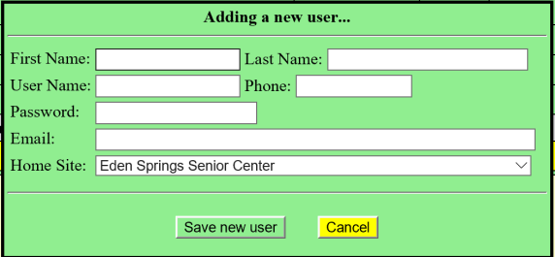Enter the information requested and click Save new user.

You can assign a password if you wish or if you leave it blank, a random password will be generated and e-mailed to the new scheduler.

If the system tells you that the email is already in use, use the search menu to find who is using that email. If their home is on some other site, that site’s Appointment Manager will have to change the Home Site to your site. (They may be in the other site’s Taxpayer list.) Or if they are an active Scheduler there, allow that site to have access to your site as described earlier and set the person’s permissions in the yellow section corresponding to their Home Site. If their home is “Unassigned”, change their home site to yours; they will then appear in your “Taxpayers” tab. There will be a new box there which, if checked, will move them to your “Schedulers” tab.

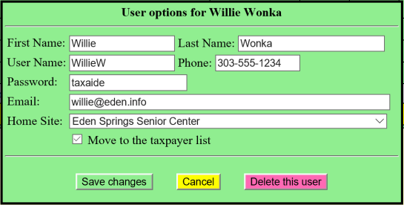Once added, click on the scheduler’s name to bring up a similar box which can then be edited as information changes.

One new checkbox near the bottom is to Move to the taxpayer list (next tab to be discussed). Check this if the Scheduler will no longer be active but wishes to retain their login access to make their own appointment on the internet. They will only, of course, be able to make a reservation for sites who have that option enabled.

You can also change a person’s home site. You might do this if your ad-hoc site that you added spins off to be a full-status site and the person will be registered with them as part of that process.

## Taxpayers list

The Taxpayer tab lists all taxpayers who have logged in and made their own appointments at your site:

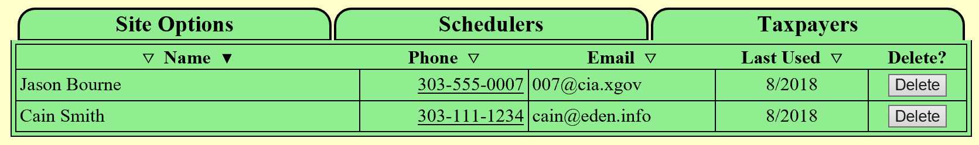

You can sort the list using the inverted triangles in the header of the table. In the Name column, the left triangle sorts by first name and the right triangle sorts by last name.

Click on the name to open their information box.

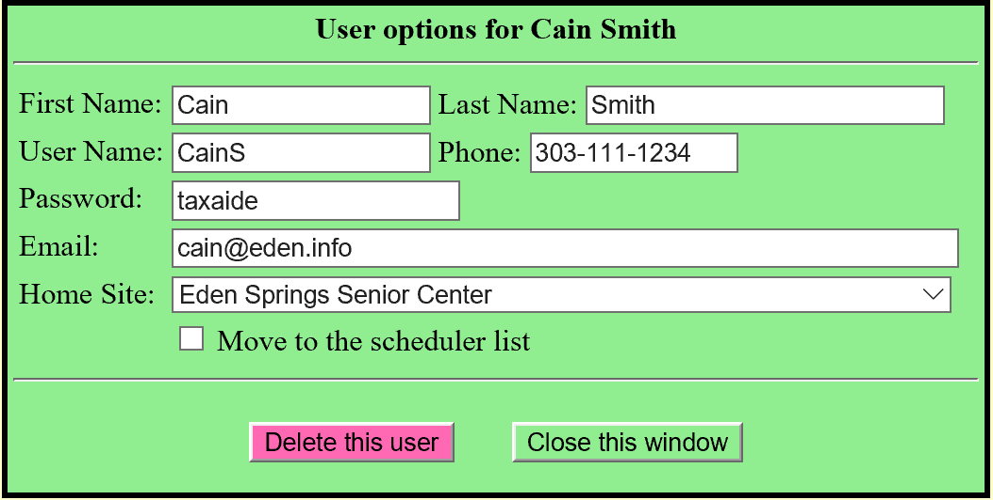If you know that this taxpayer only came to your site because they couldn’t get an appointment at another site, you can change their Home Site appropriately.

If you recruit this person to work at your site, you can move them to the scheduler list with the checkbox near the bottom. You will then have to go to the Scheduler tab and assign their Role and permissions.

As time goes on, this list may become quite lengthy so you may want to sort by “Last Used” date and delete those who haven’t logged in for a couple of years.

# Appendix 1

**Suggestions for use during the Coronavirus pandemic**

The Appointment system gives you the ability to do some things to help with the tracking for this year’s response to the Coronavirus pandemic situation. What follows are suggestions that may work for you.

Let’s start with an example of a site set up for taxpayer self-registration for an appointment:

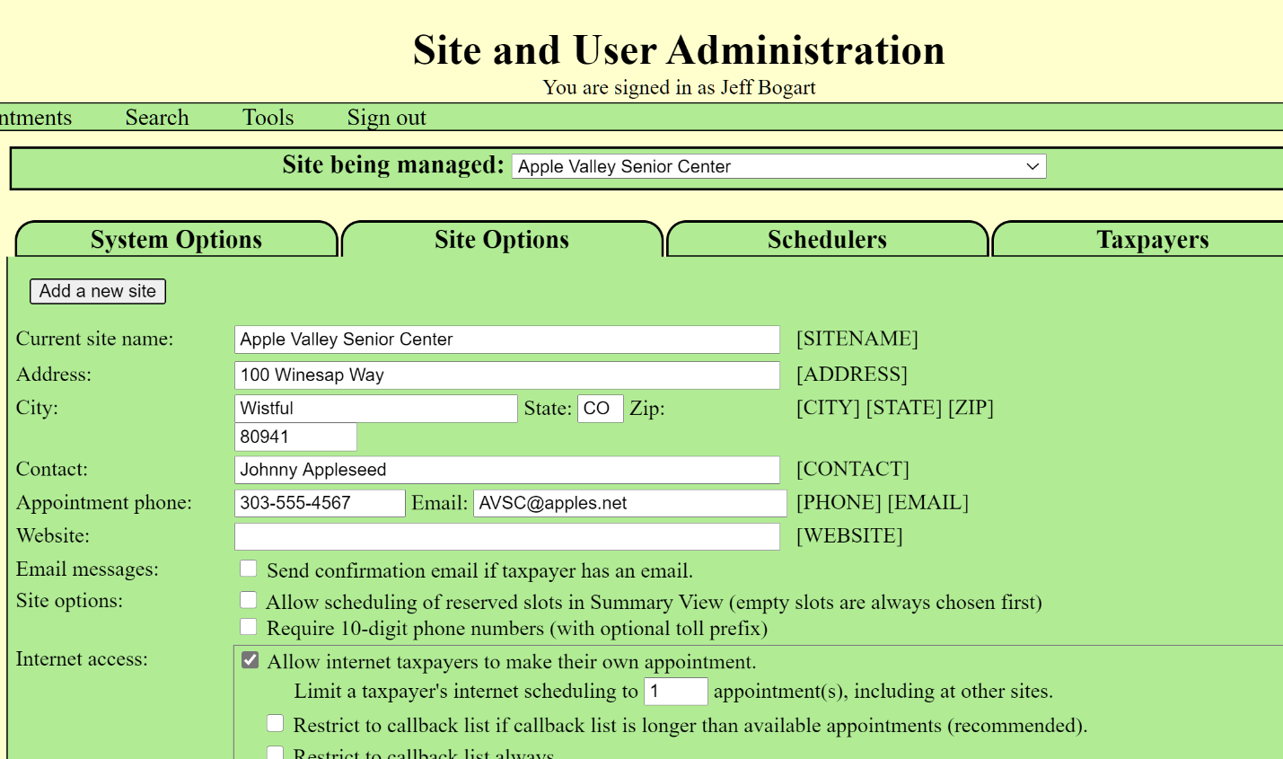

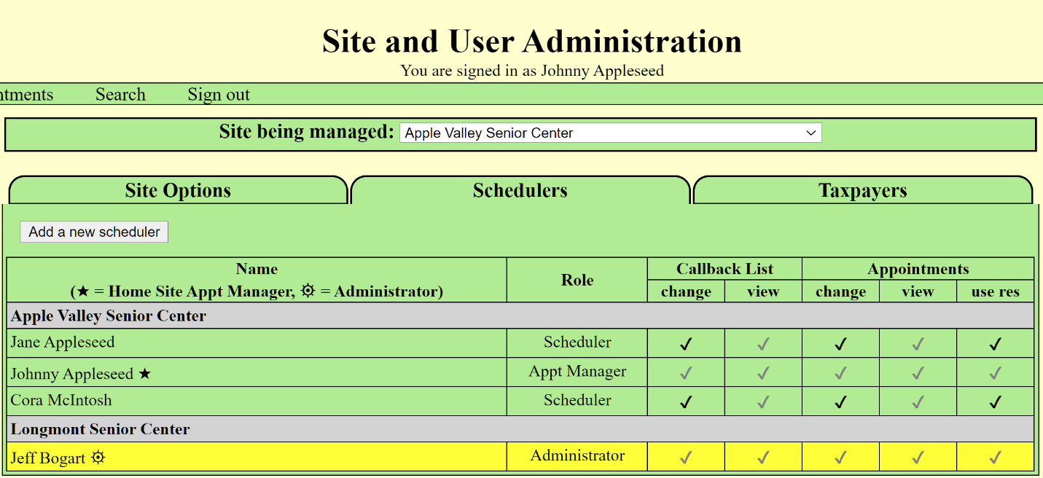

**Figure 1 - ORIGINAL SITE SETUP**

Most sites seem to be moving to a multiple-visit arrangement, one to scan documents and another to pick up the tax return and sign the permission to file. Two approaches are described:

1. Use reserved slots
2. Add a secondary site for return visits

## OPTION 1 - USE RESERVED SLOTS

If you are not using the reserved slots for other purposes, this may be a simple solution for you.

Make your initial appointments as usual and the return visit appointments as reserved. In **Figure 2**, The Summary View shows that I have set up a single appointment slot for every 30 minutes for scanning and 15 minutes for picking up the return (probably unrealistic, but it’s just an example after all). This also assumes that I have 2 stations, one for scanning and one for printing/approvals. Note that the reserved slots aren’t shown in the count for each time period, due to the option set in the Site Management screen. You can change the option to include them in the count.

Taxpayers who make their own appointments are never shown nor allowed to use reserved slots.

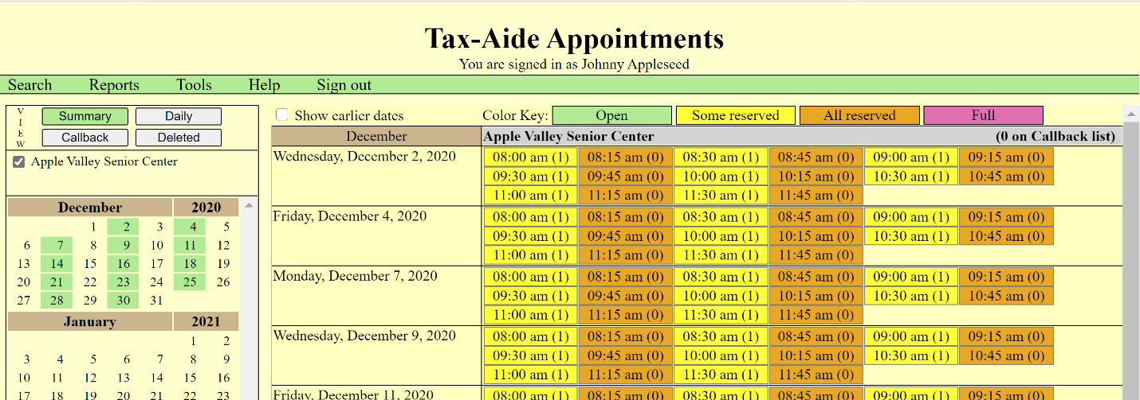

**Figure 2 – USING RESERVED SLOTS FOR RETURN VISITS**

And the daily view…

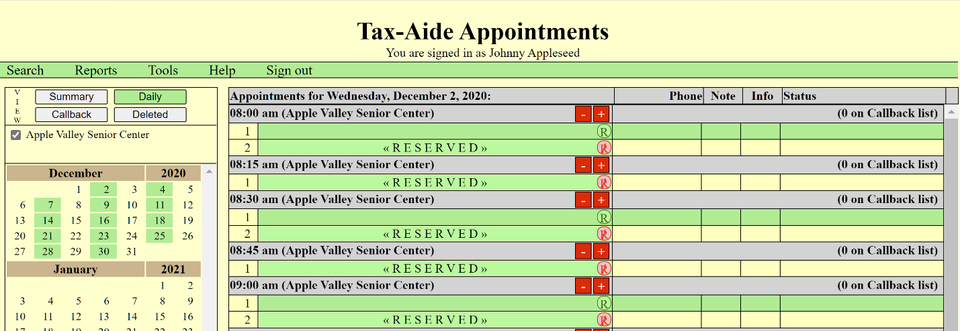

**Figure 3 - DAILY VIEW USING RESERVED SLOTS FOR RETURN VISITS**

You might want to change the permission levels of your other Schedulers to fit your situation. For example, if Cora McIntosh at the Senior Center can make appointments for you, you likely don’t want Cora to make return visit appointments. You do this by removing the permission for Cora to use the reserved slots.

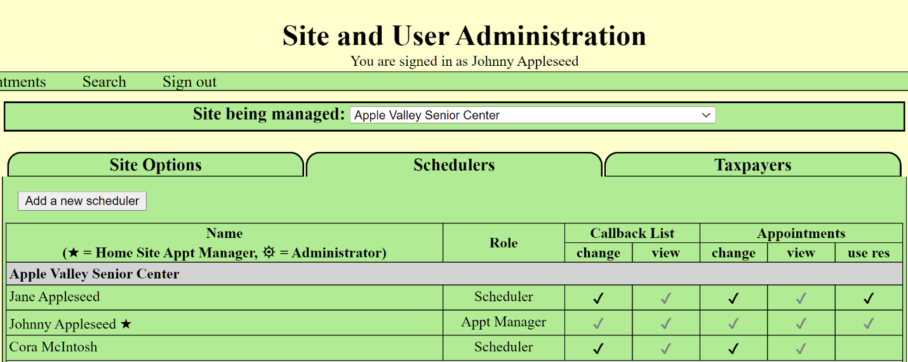

**Figure 4 - PREVENT CORA FROM USING RESERVED SLOTS**

## OPTION 2 - SETTING UP A SECOND SITE

The second suggestion is to create a duplicate site with the same name but an added comment on the end such as “ – return visit”, as shown in **Figure 5**. For this duplicate site, do not allow the taxpayer to make their own appointment. You will be making that when you know the return has been completed.

Check the box to allow your original site to view or schedule this new site and check the box next to your original site. This will cause your original site scheduler list to appear on your new site’s Schedulers tab.

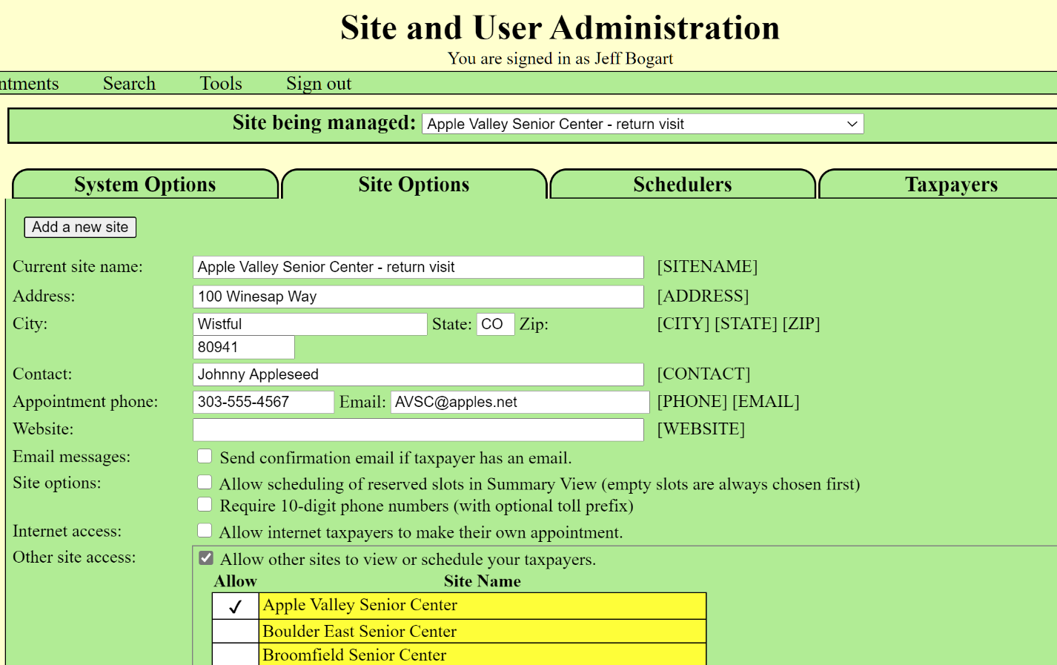

**Figure 5 - NEW DUPLICATE SITE FOR RETURN VISITS**

Then go to the Scheduler tab and set the permissions for your original site schedulers that you want for the return visit site (**Figure 6**). Be sure to give your Appt Managers that same permission! You might want to change the permission levels of your other Schedulers to fit your situation. For example, if Cora McIntosh at the Senior Center can make appointments for you, you likely don’t want Cora to make or even see return visit appointments.

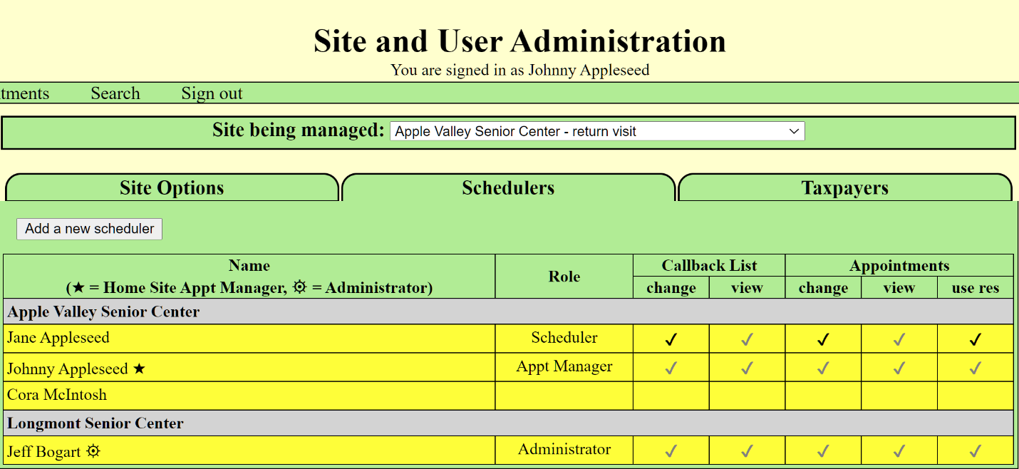

**Figure 6 - PERMISSIONS FOR YOUR RETURN VISIT SITE**

The next step is to set up your schedules for each site. In **Figure 7**, The Summary View shows that I have set up a single appointment slot for every 30 minutes for scanning and 15 minutes for picking up the return (probably unrealistic, but it’s just an example after all). This also assumes that I have 2 stations, one for scanning and one for printing/approvals.

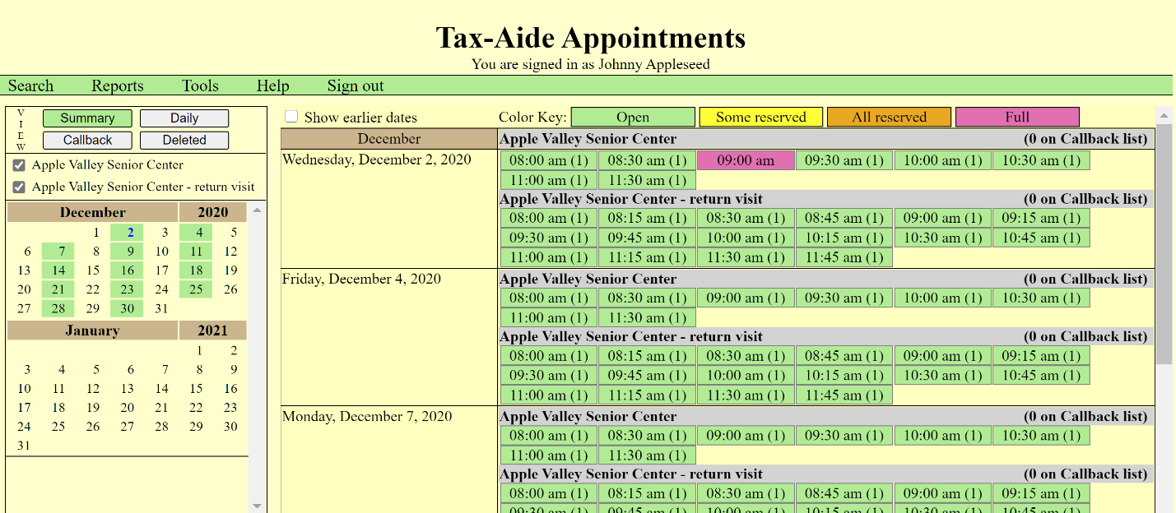

**Figure 7 - SUMMARY VIEW SHOWING ALL APPOINTMENTS**

You can check or un-check the boxes in the site list to show just the original or the return visit schedules. In our example where Cory McIntosh did not have permission for the return visit site, Cory would not have a box to check for that site.

The Daily View (**Figure 8**) gets pretty cluttered with all the time slot headers (sorry about that) so you may not want to display both sites at once. Check-in sheets and tracking sheets for each site must be printed individually but the Excel export can include both.

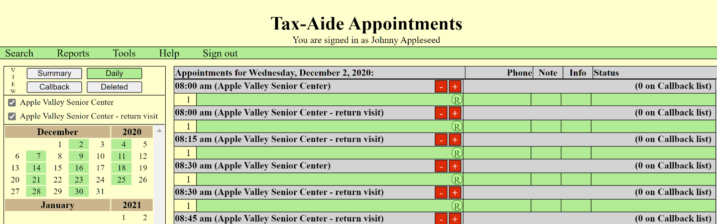

**Figure 8 - DAILY VIEW SHOWING ALL APPOINTMENTS FOR THE DAY**

## NEW TAXPAYER PROCESS MESSAGE

If you are allowing the taxpayer to make their own appointment, there is a new field that explains to them how the process will work at your site. Do not cut and paste from a word document – some characters like em-dashes, apostrophes, quotes and bullet lists don’t always transfer properly. Create it (or save it) as a txt file first. **Figure 9** shows where to add this text and **Figure 10** shows what it looks like when the taxpayer logs in to make the appointment.

(NOTE FOR GEEKS: If you are familiar with HTML, you can include it in your message.)

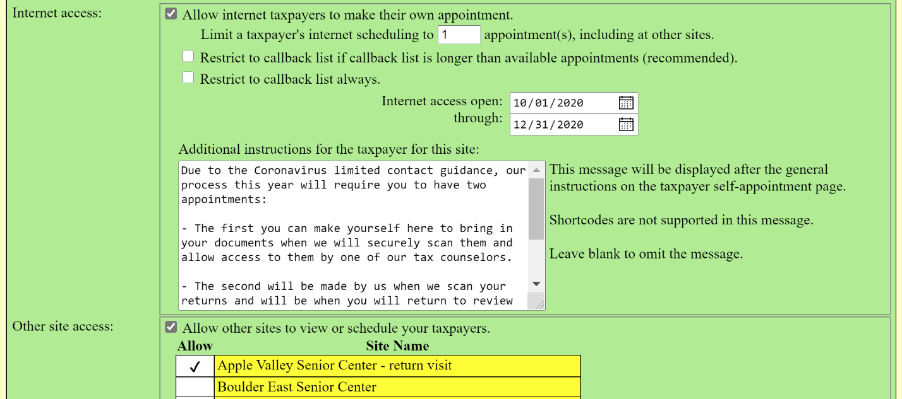

**Figure 9 - ADDING THE INSTRUCTIONS TEXT MESSAGE**

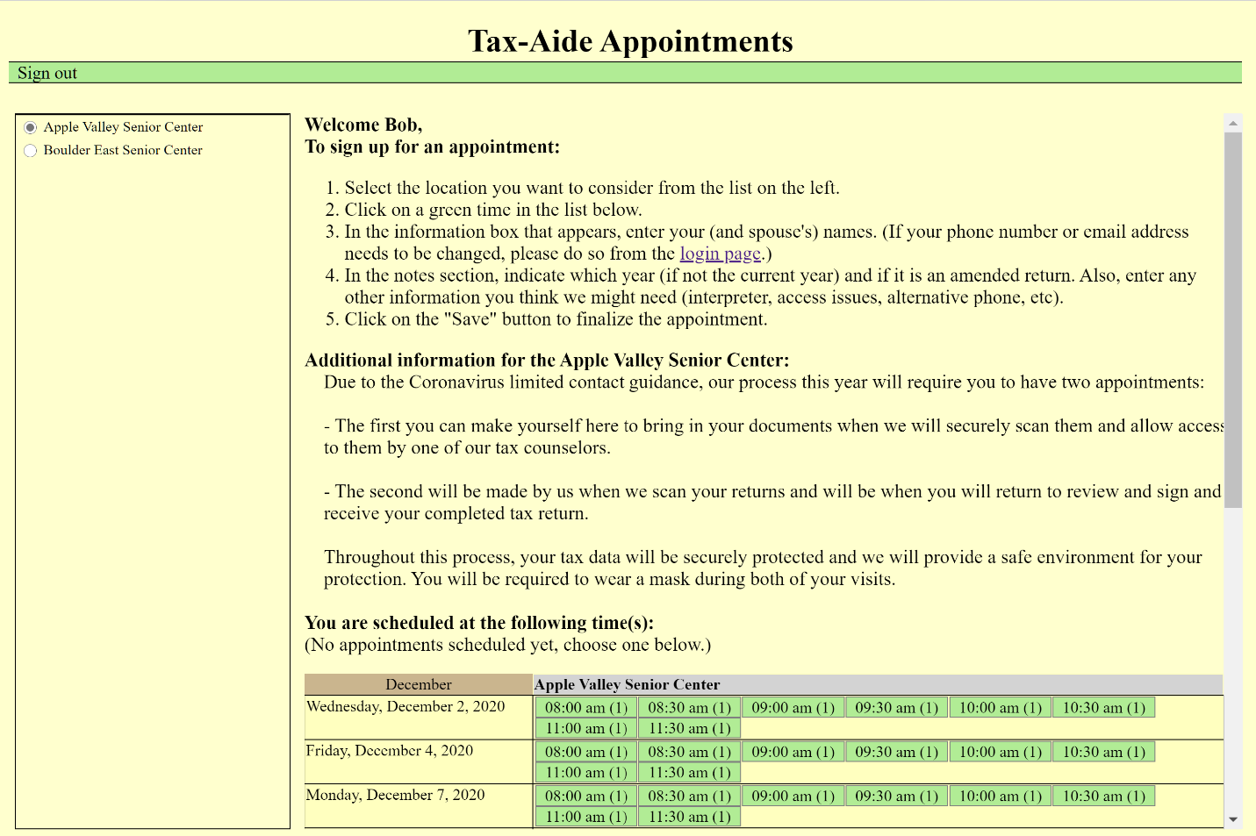

**Figure 10 - ADDITIONAL INFORMATION MESSAGE ON TAXPAYER APPOINTMENT SCREEN**

Notice in **Figure 10** that only your original site is listed because internet taxpayer self-registration is not turned on for the return visit site.

If you use the “Send confirmation email…” option, the name you have chosen for the return visit site will be sent in the confirmation/reminder email for that appointment – another good reason to use the suggested naming for your return visit site.

## TAXPAYER TRACKING

**Figure 11** shows the details for a taxpayer who has made an appointment.

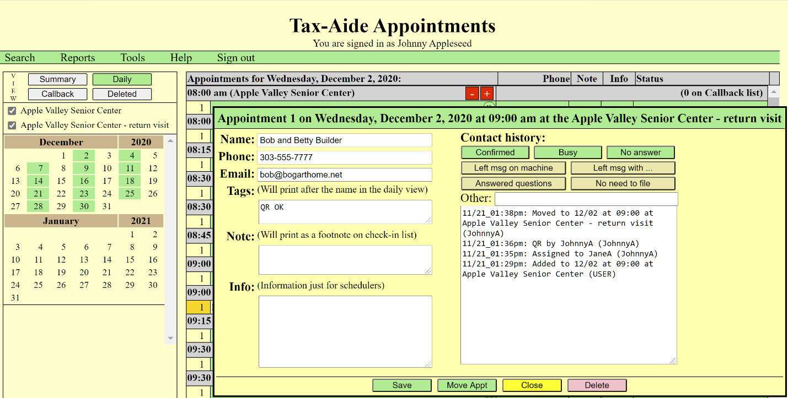

**Figure 11 - TAXPAYER APPONTMENT DETAILS**

Tracking this year will be complicated and will likely be managed by your Virtual Return Coordinator (VRC). The various fields available may assist in the task.

The “Tags” entry will appear with the name in the daily view and can be used for searching. This is a good place to use unique tags to indicate the status of the taxpayer and could be used to compare with the status of the return in TaxSlayer. Searching for a tag will show anyone, at any site in the system that matches, so you may want to make your tags quite unique.

The “Content history” section, using the “Other” entry is a way to enter to whom and when this taxpayer’s return has been assigned. When a tax return has been completed and an appointment is to be made for the taxpayer to return for signatures and a printed copy, I suggest copying the appointment from your original site to the reserved slot or the return visit site (rather than re-entering the taxpayer’s name) so that the history is maintained in the same taxpayer record.

One of the reports you can print is the QR tracking sheet and could be used for tracking as it has been for on-site tax preparation.